Logical Entity-Relationship Diagram
KAVERI 3.0 — User Management & Role-Based Access Control

1. Document control
Field | Value
Document ID | ERD-K3-UM-001
Version | 2.3
Status | Draft / companion to BRD v1.0 (11-Sep-2026)
Project | KAVERI 3.0 — Department of Stamps and Registration
Module | User Management & RBAC
Source BRD | Finalized BRD/User Management/BRD_User_Management_v1.0.pdf
Relationship to BRD | Separate companion document — not a section of the BRD
Author (BA) | Nandha Kumar
Product Owner | M V Prashanth
Domain expert | Prabhakar Naik
Last updated | 2026-09-17
Physical DDL | Finalized BRD/User Management/DDL/ (PostgreSQL)

Version | Date | Summary
1.0 | 2026-08-30 | Initial logical ERD derived from User Management BRD v4.8 masters, FRs, and occupancy / RBAC rules.
2.0 | 2026-09-01 | Revised for BRD v4.16: requirement IDs aligned to FR-UM-nnn convention; logical model unchanged.
2.1 | 2026-09-05 | Aligned to BRD v4.18: TEMPORARY_ABSENCE and TEMPORARY_CHARGE (FR-UM-079–FR-UM-084); USER_SESSION context for temporary charge; companion PostgreSQL DDL scripts.
2.2 | 2026-09-05 | officer_hierarchy_node division/effective dates; persisted remaining_capacity / is_wholly_unoccupied; nullable last_name; module/function/resource attribute completeness.
2.3 | 2026-09-17 | Aligned to finalized BRD v1.0 (11-Sep-2026): Aadhaar e-KYC replaces security questions (FR-UM-055 retired, FR-UM-085); reserved Transfer In / Joining Date retired (FR-UM-061, FR-UM-067); DSR no official email and no login OTP; Other Department username DeptCode-EmpID; session idle 10 min / absolute 4 h; relieving_reason enum.

2. Purpose and scope
This document is the logical data model for the User Management module. It is issued as a stand-alone engineering / BA companion so that the BRD remains a requirements document. Physical DDL for PostgreSQL is provided alongside this ERD under DDL/; implementers may split or merge tables provided the business keys, cardinalities, and rules below are preserved.
In scope: masters, mappings, identity, occupancy / transfer, temporary absence / temporary charge, Aadhaar e-KYC, session / OTP, RBAC resources, and audit.
Out of scope: citizen service case data (Marriage, Document Registration, etc.), Khajane-II DDO tables owned by Treasury, and Application Admin as a Role Master row (FR-UM-051 — seeded system principal).

3. Logical ERD
Four figures follow. Colour bands group subject areas. Occupied count on SANCTIONED_POST is maintained by the occupancy refresh job (FR-UM-068) and is shown as a stored derived attribute, not a separate entity. Temporary Absence does not change Occupied (FR-UM-081). Full attributes and cardinalities are in sections 5 and 6.
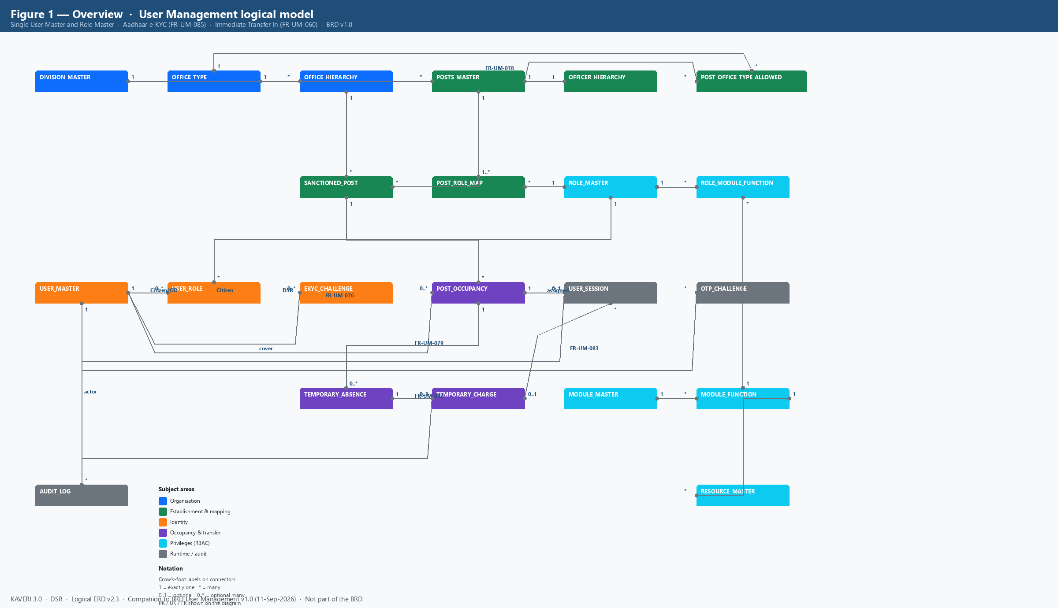
Figure 1. Overview — all logical entities and cardinalities (BRD v1.0)
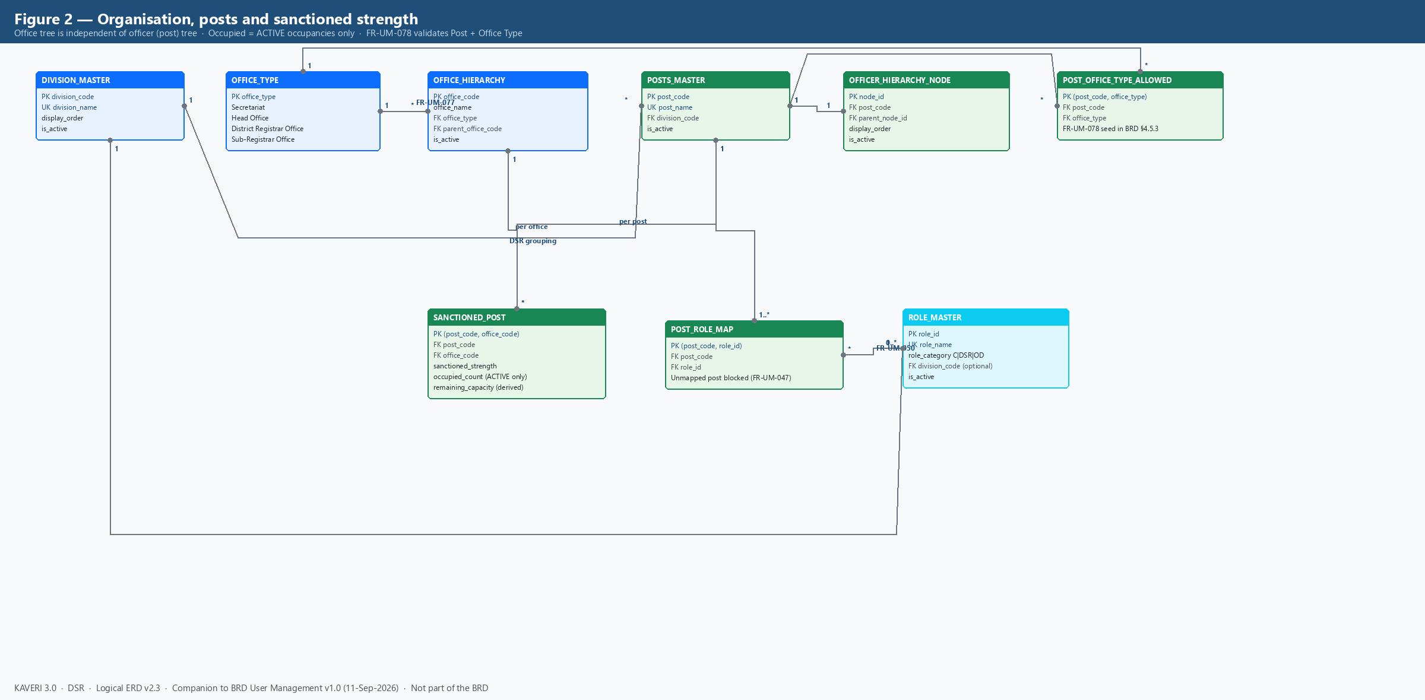
Figure 2. Organisation, posts, sanctioned strength and Post–Role mapping
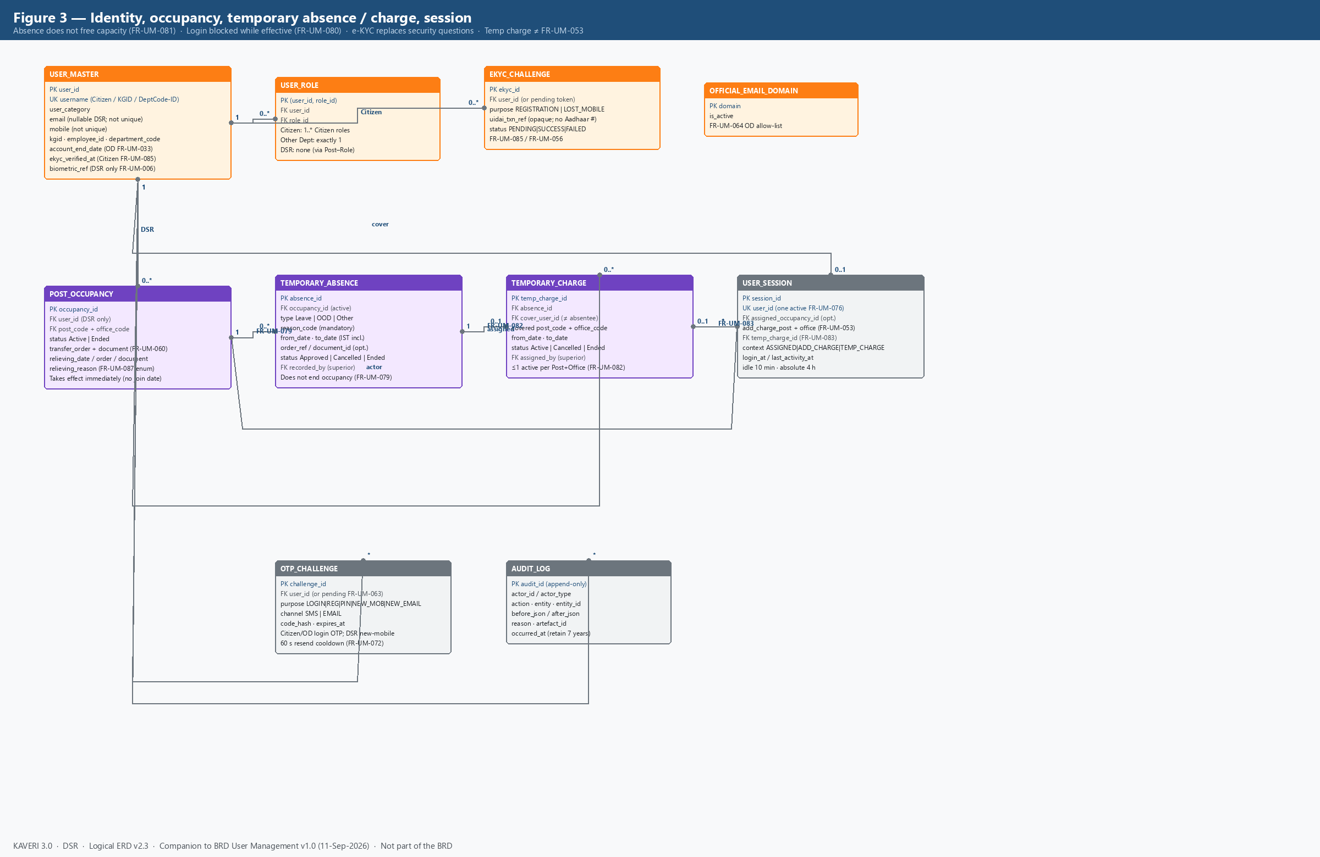
Figure 3. Identity, occupancy, temporary absence / charge, session, OTP and audit
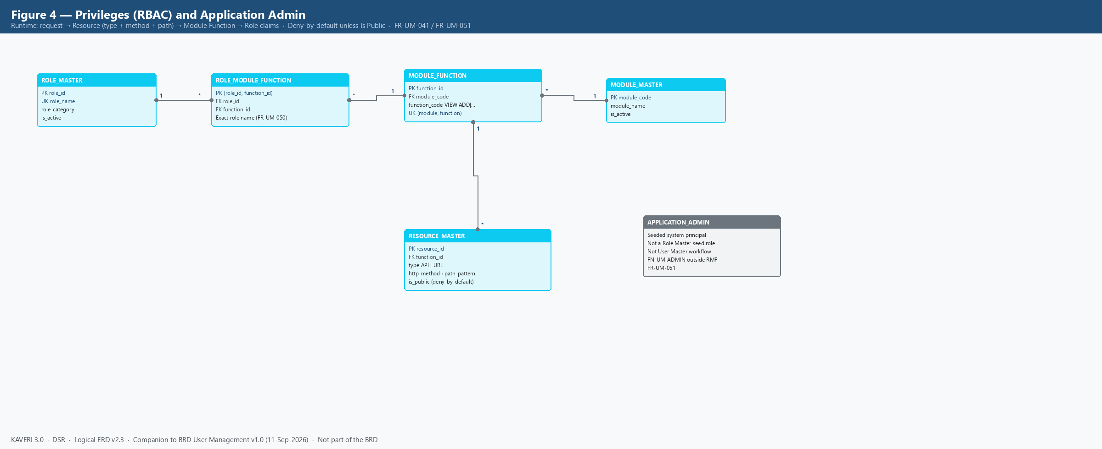
Figure 4. RBAC path Role → Module Function → Resource; Application Admin (FR-UM-051)

4. Subject-area summary
Area | Entities | BRD anchors
Organisation | DIVISION_MASTER, OFFICE_TYPE, OFFICE_HIERARCHY | FR-UM-059, FR-UM-077; §4.5.1, §4.5.8
Establishment | POSTS_MASTER, OFFICER_HIERARCHY_NODE, POST_OFFICE_TYPE_ALLOWED, SANCTIONED_POST, POST_ROLE_MAP | FR-UM-024, FR-UM-043–FR-UM-049, FR-UM-066–FR-UM-068, FR-UM-078; §4.5.3, §4.5.7
Identity | USER_MASTER, USER_ROLE, EKYC_CHALLENGE, OFFICIAL_EMAIL_DOMAIN | FR-UM-001–FR-UM-004, FR-UM-016, FR-UM-033–FR-UM-035, FR-UM-056, FR-UM-062–FR-UM-065, FR-UM-085, FR-UM-086
Occupancy & transfer | POST_OCCUPANCY (Transfer In / Relieving / deputation End Date as attributes) | FR-UM-026, FR-UM-030, FR-UM-052, FR-UM-057–FR-UM-060, FR-UM-066–FR-UM-068, FR-UM-087
Temporary absence & charge | TEMPORARY_ABSENCE, TEMPORARY_CHARGE; USER_SESSION.temp_charge_id | FR-UM-079–FR-UM-084; §4.6.6; distinct from FR-UM-053
RBAC | ROLE_MASTER, MODULE_MASTER, MODULE_FUNCTION, RESOURCE_MASTER, ROLE_MODULE_FUNCTION | FR-UM-018, FR-UM-036–FR-UM-042, FR-UM-050–FR-UM-051
Runtime / audit | USER_SESSION, OTP_CHALLENGE, AUDIT_LOG; APPLICATION_ADMIN (not a Role Master entity) | FR-UM-005–FR-UM-013, FR-UM-022, FR-UM-051, FR-UM-069–FR-UM-076, FR-UM-085–FR-UM-086

5. Entity catalogue

5.1 DIVISION_MASTER
Enumerated DSR organisational divisions. Free-text division labels are not permitted on new or edited records (FR-UM-077).
Attribute | Type / notes | Constraints
division_code | String, e.g. DIV-ENFORCEMENT | PK
division_name | String | UK; required
display_order | Integer | Seed 1–8
is_active | Boolean | Soft disable

5.2 OFFICE_TYPE
Lookup of Secretariat, Head Office, District Registrar Office, Sub-Registrar Office. Distinct from role names (SRO is an office type, not a Role Master name).
Attribute | Type / notes | Constraints
office_type | Enum / code | PK
display_name | String | Required

5.3 OFFICE_HIERARCHY
Concrete DSR offices. Tree: MS Building (Secretariat, root, OFF-MS-BLDG) → IGR Office (Head Office) → District Registrar Offices → Sub-Registrar Offices (FR-UM-059). Office span for Transfer Out / Transfer In is the session office plus descendants.
Attribute | Type / notes | Constraints
office_code | String, e.g. OFF-SRO-YESH | PK
office_name | String | Required
office_type | FK OFFICE_TYPE | Required
parent_office_code | FK OFFICE_HIERARCHY | Null only for MS Building
is_active | Boolean | Soft disable with audit

5.4 POSTS_MASTER
DSR establishment posts, distinct from Role Master. Division-specific posts (FR-UM-049). Post name is the referential-integrity key used by Post–Role and Hierarchy (FR-UM-050).
Attribute | Type / notes | Constraints
post_code | String, e.g. POST-SR | PK
post_name | String, character-for-character match | UK; required
division_code | FK DIVISION_MASTER | Required (FR-UM-077)
is_active | Boolean | Soft disable

5.5 OFFICER_HIERARCHY_NODE
Reporting tree of Posts (not of people). Each node references a Post; optional parent is also a Post node (FR-UM-043, FR-UM-044). Used for FR-UM-053 additional-charge cascade and Transfer Out / In immediate-parent filter.
Attribute | Type / notes | Constraints
node_id | Surrogate | PK
post_code | FK POSTS_MASTER | UK recommended (one node per post)
parent_node_id | FK self | Null at ACS / Secretary
division_code | FK DIVISION_MASTER | Required (Section 4.5.7)
display_order | Integer | Sort among siblings
level | Derived integer (view) | 0 = root; not stored
effective_from / to | Date | Optional validity of the link
is_active | Boolean | Soft disable; history retained

5.6 POST_OFFICE_TYPE_ALLOWED
Which Post codes may be sanctioned at which Office Types (FR-UM-078). Example: POST-ACS-SEC only at Secretariat; POST-SR / POST-FDA-ENF / POST-DEO only at Sub-Registrar Office.
Attribute | Type / notes | Constraints
post_code | FK POSTS_MASTER | PK part
office_type | FK OFFICE_TYPE | PK part

5.7 SANCTIONED_POST
Approved headcount per Post at each Office (FR-UM-024, FR-UM-048). Occupied count includes ACTIVE occupancies only and is recalculated by the midnight occupancy refresh job (FR-UM-068). Reserved Transfer In is retired (FR-UM-067). FR-UM-066(a) available capacity = Occupied < Strength. FR-UM-066(b) wholly unoccupied = Occupied = 0 (FR-UM-053).
Attribute | Type / notes | Constraints
post_code | FK POSTS_MASTER | PK part; must have Post–Role mapping (FR-UM-047)
office_code | FK OFFICE_HIERARCHY | PK part
sanctioned_strength | Integer ≥ 0 | Required
occupied_count | Integer, job-maintained | ACTIVE occupancies only
remaining_capacity | Derived Strength − Occupied | May be stored or computed

5.8 ROLE_MASTER
Single role catalogue for Citizen, DSR, and Other Department (FR-UM-016, FR-UM-035). Unique role names include division context (FDA (Enforcement), not bare FDA). Application Admin is not a seed row (FR-UM-051).
Attribute | Type / notes | Constraints
role_id | Surrogate | PK
role_name | String | UK; FR-UM-050 exact match
role_category | Citizen | DSR | Other Department | Required
division_code | FK DIVISION_MASTER | Optional; DSR seed grouping
description | String | Optional
is_active | Boolean | Disable blocked if still in use

5.9 POST_ROLE_MAP
One Post may map to multiple Roles only within the same functional scope (FR-UM-047). Sanction or assignment of an unmapped Post is blocked. DSR session privileges come from this mapping for the selected occupancy — not from USER_ROLE.
Attribute | Type / notes | Constraints
post_code | FK POSTS_MASTER | PK part
role_id | FK ROLE_MASTER | PK part; name must match Role Master

5.10 USER_MASTER
Single user store. Username is the only unique login identifier (FR-UM-004, FR-UM-062): preferred Username for Citizens; KGID for DSR Officers; Department Code concatenated with Employee ID or KGID for Other Department users. Email and mobile are not unique. DSR Officers do not capture official email (FR-UM-002, FR-UM-064). No password attribute exists (FR-UM-009). Citizen Aadhaar e-KYC is mandatory at registration (FR-UM-085).
Attribute | Type / notes | Constraints
user_id | Surrogate | PK
username | Citizen preferred / DSR KGID / OD DeptCode-ID | UK across all categories
user_category | Public (Citizen) | DSR Officer | Other Department | Required
name_parts | First / middle / last | first_name required; last_name nullable
email | Citizen personal / OD official; null for DSR | Not unique; FR-UM-064 domain check for OD
mobile | SMS OTP target (Citizen/OD login; DSR new-mobile) | Not unique
kgid | String | Required unique for DSR; equals username
employee_id / department_code | String | Other Department username parts
parent_department / designation | String | Other Department only
account_end_date | Date | Optional; OD auto-deactivate (FR-UM-033)
status | Active | Suspended | Deactivated | Deactivation requires reason
lockout_until | Timestamp | FR-UM-073 login lock 15 min
reset_lockout_until | Timestamp | FR-UM-056 reset-flow lock
ekyc_verified_at | Timestamp | Citizen only (FR-UM-085)
biometric_ref | UIDAI-compliant token | DSR only; every login (FR-UM-006)
photo / id_proof_ref | Document store keys | Departmental creation
authorisation_letter_ref | Document store | Other Department should

5.11 USER_ROLE
Direct role assignment for Citizens (one or more Citizen-category roles) and Other Department users (exactly one Other Department role — FR-UM-017 / FR-UM-034). DSR Officers do not receive USER_ROLE rows; their roles are resolved Post occupancy → POST_ROLE_MAP at login (FR-UM-052, FR-UM-038).
Attribute | Type / notes | Constraints
user_id | FK USER_MASTER | PK part
role_id | FK ROLE_MASTER | PK part; Role Category must match User Category

5.12 EKYC_CHALLENGE
Aadhaar e-KYC attempts for Citizen self-registration and lost-mobile reset (FR-UM-085, FR-UM-056). Stores opaque UIDAI transaction references and consent timestamps only. Aadhaar number and VID are never stored. Security questions are retired (FR-UM-055) and are not entities in this model.
Attribute | Type / notes | Constraints
ekyc_id | Surrogate | PK
user_id | FK USER_MASTER | Nullable during registration (pending token)
pending_token | String | Pre-account registration correlation
purpose | REGISTRATION | LOST_MOBILE | Required
uidai_txn_ref | Opaque UIDAI transaction id | Never the Aadhaar number
status | PENDING | SUCCESS | FAILED | Required
consent_captured_at | Timestamp | UIDAI consent
attempt_count | Integer | Rate-limit / lockout input

5.13 OFFICIAL_EMAIL_DOMAIN
Optional allow-list for Other Department official email (FR-UM-064). Not used for DSR Officers, who do not capture official email.
Attribute | Type / notes | Constraints
domain | e.g. karnataka.gov.in | PK
is_active | Boolean

5.14 POST_OCCUPANCY
Assignment of a DSR user to a sanctioned Post at an Office. Multiple occupancies per user are allowed. Transfer In and Relieving are modelled as attributes and status on this entity rather than separate header tables. Transfer In is allowed only when Occupied < Sanctioned Strength and becomes ACTIVE immediately (FR-UM-060). Joining Date, reserved occupancy, and occupancy End Date / deputation reason are retired (FR-UM-061, FR-UM-067, FR-UM-030).
Attribute | Type / notes | Constraints
occupancy_id | Surrogate | PK
user_id | FK USER_MASTER | User Category = DSR Officer
post_code + office_code | FK SANCTIONED_POST | Must have available capacity (FR-UM-066(a))
status | Active | Ended | Job ends after Relieving Date (FR-UM-068)
transfer_order_no / document_id | String / artefact | FR-UM-060; no Joining Date
relieving_date | Date | Mapping retained through 23:59 IST of that date
relieving_reason | Deputation | Transfer | Suspension | Superannuation | Death | Mandatory with relieving_date (FR-UM-087)
relieving_order_no / document_id | String / artefact | FR-UM-057
created_by / created_at | Actor + timestamp | Immediate-parent + office-span rules

5.15 USER_SESSION
One active session per Username (FR-UM-076). Idle 10 minutes (FR-UM-074); absolute 4 hours (FR-UM-075). For DSR: session context is exactly one of (a) assigned occupancy (FR-UM-052), (b) additional charge of a wholly unoccupied subordinate post at the same office (FR-UM-053 — session-only, no occupancy row), or (c) temporary charge of an absent Post + Office (FR-UM-083 — FK temp_charge_id). While additional charge or temporary charge is active, Module Function claims come only from that covered post (FR-UM-038).
Attribute | Type / notes | Constraints
session_id | Surrogate | PK
user_id | FK USER_MASTER | UK among active sessions
session_context | ASSIGNED | ADDITIONAL_CHARGE | TEMPORARY_CHARGE | DSR only; null for Citizen / OD
assigned_occupancy_id | FK POST_OCCUPANCY | Required when context = ASSIGNED; optional anchor otherwise
add_charge_post_code | FK POSTS_MASTER | Optional; FR-UM-053; same office as assigned
add_charge_office_code | FK OFFICE_HIERARCHY | Must equal assigned occupancy office
temp_charge_id | FK TEMPORARY_CHARGE | Required when context = TEMPORARY_CHARGE (FR-UM-083)
login_at / last_activity_at / expires_at | Timestamps | IST clock

5.16 TEMPORARY_ABSENCE
Superior-recorded Leave / OOD / Other period linked to an active DSR post occupancy (FR-UM-079). Does not end the occupancy and does not free sanctioned capacity (FR-UM-081). While an Approved absence covers the current IST calendar day (effective absence), login is denied for the Username across all posts (FR-UM-080). Scope to create/amend/cancel matches Transfer Out: office span + immediate-parent post parentage. Cleared after 23:59 IST of to_date by the occupancy refresh job or equivalent day-boundary evaluation (FR-UM-084 / FR-UM-068); superior cancel takes effect immediately.
Attribute | Type / notes | Constraints
absence_id | Surrogate | PK
occupancy_id | FK POST_OCCUPANCY | Must be Active; DSR only
absence_type | Leave | OOD | Other | Required
reason_code | Code / string | Mandatory
from_date | Date (IST) | Inclusive; required
to_date | Date (IST) | Inclusive; ≥ from_date
order_ref / document_id | String / artefact | Optional
status | Approved | Cancelled | Ended | Ended by FR-UM-084 job or cancel
recorded_by | FK USER_MASTER | Hierarchy superior
cancelled_by / cancelled_at | Actor + timestamp | Optional; immediate effect
created_at | Timestamp IST | Required; audit-logged

5.17 TEMPORARY_CHARGE
Superior-assigned mapping of an absent Post + Office to a covering DSR Officer under the same superior (FR-UM-082). May be cross-office within office span. Distinct from FR-UM-053 session additional charge (which requires wholly unoccupied subordinate post at the same office). Cover officer must not be the absentee and must not themselves be under effective absence. At most one Active charge per Post + Office. At FR-UM-052 the cover officer sees temporary-charge rows alongside own assigned posts (FR-UM-083).
Attribute | Type / notes | Constraints
temp_charge_id | Surrogate | PK
absence_id | FK TEMPORARY_ABSENCE | Required; same date window
cover_user_id | FK USER_MASTER | ≠ absentee; DSR Officer
covered_post_code + covered_office_code | From absent occupancy / SANCTIONED_POST | Required
from_date / to_date | Date (IST) | Within or equal to absence window
status | Active | Cancelled | Ended | Ended by FR-UM-084 or cancel
assigned_by | FK USER_MASTER | Hierarchy superior
order_ref / document_id | String / artefact | Optional
created_at / cancelled_at | Timestamps | Audit-logged

5.18 OTP_CHALLENGE
OTP/PIN issuance for Citizen and Other Department login (SMS only — DSR login uses face/biometric, FR-UM-006), Citizen registration (email + mobile), lost-mobile PIN (email, FR-UM-056), and new-mobile / new-email verification including DSR self-service mobile change (FR-UM-086). Policy FR-UM-069–FR-UM-072: 6 digits; login 5 min; registration/PIN 10 min; 3 failures invalidate; 60 s resend; max 3 resends / 15 min.
Attribute | Type / notes | Constraints
challenge_id | Surrogate | PK
user_id | FK USER_MASTER (or pending registration token) | Nullable during FR-UM-063
purpose | LOGIN | REG_EMAIL | REG_MOBILE | RESET_PIN | NEW_MOBILE | NEW_EMAIL | LOGIN not used for DSR
channel | SMS | EMAIL | Login OTP never emailed (FR-UM-010)
code_hash | Hash | Never stored clear
expires_at / attempt_count / resend_count | Policy attributes | FR-UM-069–FR-UM-072

5.19 MODULE_MASTER, MODULE_FUNCTION, RESOURCE_MASTER, ROLE_MODULE_FUNCTION
Access path: session roles → ROLE_MODULE_FUNCTION → MODULE_FUNCTION → RESOURCE. Runtime match is Type + Method + Path with most-specific pattern winning; unmatched non-public resources deny (FR-UM-041). Is Public = Yes allows unauthenticated access. Application Admin uses FN-UM-ADMIN outside this mapping (FR-UM-051).
Entity | Key attributes | Notes
MODULE_MASTER | module_code, module_name, is_active | e.g. Marriage Registration, Encumbrance Search
MODULE_FUNCTION | function_id, module_code, function_code | VIEW, ADD, EDIT, APPROVE, SIGN, PRINT, DOWNLOAD, FN-UM-ADMIN
RESOURCE_MASTER | resource_id, function_id, type, method, path_pattern, is_public | Roles do not store raw URL lists
ROLE_MODULE_FUNCTION | role_id, function_id | Role name must match Role Master exactly (FR-UM-050)

5.20 AUDIT_LOG
Append-only log of create/update/delete, login, mobile/email change, lost-mobile reset, Transfer Out / In, additional charge switch, temporary absence / temporary charge create-amend-cancel, occupancy-refresh job, and access denials. Retention at least seven years. Who, when, before/after, reason, artefact id.
Attribute | Type / notes | Constraints
audit_id | Surrogate | PK; no updates/deletes
actor_id / actor_type | User or job / Application Admin | Required
action / entity / entity_id | String | Required
before_json / after_json | JSON | Masked PII (mobile)
reason / artefact_id | String | GO / order document
occurred_at | Timestamp IST | Required

6. Relationship catalogue
Parent | Child | Cardinality | Rule
DIVISION_MASTER | POSTS_MASTER | 1 : * | Every post has a Division Code (FR-UM-077).
DIVISION_MASTER | ROLE_MASTER | 1 : 0..* | Optional grouping for DSR seed roles.
OFFICE_TYPE | OFFICE_HIERARCHY | 1 : * | Four office types only.
OFFICE_HIERARCHY | OFFICE_HIERARCHY | 1 : 0..* | Parent office; MS Building is root.
POSTS_MASTER | OFFICER_HIERARCHY_NODE | 1 : 1 | Every hierarchy node Post exists in Posts Master (FR-UM-044).
OFFICER_HIERARCHY_NODE | OFFICER_HIERARCHY_NODE | 1 : 0..* | Immediate parent post (FR-UM-043).
POSTS_MASTER | POST_OFFICE_TYPE_ALLOWED | 1 : * | FR-UM-078; required before sanction.
OFFICE_TYPE | POST_OFFICE_TYPE_ALLOWED | 1 : * | FR-UM-078.
POSTS_MASTER | SANCTIONED_POST | 1 : * | Strength is per Post per Office.
OFFICE_HIERARCHY | SANCTIONED_POST | 1 : * | Office Type must be allowed for that Post.
POSTS_MASTER | POST_ROLE_MAP | 1 : 1..* | Unmapped post cannot be sanctioned or assigned (FR-UM-047).
ROLE_MASTER | POST_ROLE_MAP | 1 : 0..* | Exact unique role name (FR-UM-050).
USER_MASTER | USER_ROLE | 1 : 0..* | 0 for DSR; 1 for Other Department; 1..* for Citizen.
ROLE_MASTER | USER_ROLE | 1 : 0..* | Role Category must equal User Category (FR-UM-034).
USER_MASTER | EKYC_CHALLENGE | 1 : 0..* | Citizens only (FR-UM-085, FR-UM-056).
USER_MASTER | POST_OCCUPANCY | 1 : 0..* | DSR Officers only; multiple posts allowed (FR-UM-026).
SANCTIONED_POST | POST_OCCUPANCY | 1 : 0..* | Blocked when Occupied ≥ Strength (FR-UM-060, FR-UM-066(a)).
POST_OCCUPANCY | TEMPORARY_ABSENCE | 1 : 0..* | FR-UM-079; does not end occupancy; Occupied unchanged (FR-UM-081).
TEMPORARY_ABSENCE | TEMPORARY_CHARGE | 1 : 0..1 active | ≤1 active charge per Post+Office (FR-UM-082).
USER_MASTER | TEMPORARY_CHARGE | 1 : 0..* | Cover officer; ≠ absentee; not under effective absence.
USER_MASTER | USER_SESSION | 1 : 0..1 active | Last-login-wins (FR-UM-076).
POST_OCCUPANCY | USER_SESSION | 1 : 0..* | Assigned post for DSR session (FR-UM-052).
TEMPORARY_CHARGE | USER_SESSION | 1 : 0..* | Session context TEMPORARY_CHARGE (FR-UM-083).
USER_MASTER | OTP_CHALLENGE | 1 : 0..* | Also used pre-account for FR-UM-063.
MODULE_MASTER | MODULE_FUNCTION | 1 : * | FR-UM-039.
MODULE_FUNCTION | RESOURCE_MASTER | 1 : * | FR-UM-040.
ROLE_MASTER | ROLE_MODULE_FUNCTION | 1 : * | Except Application Admin (FR-UM-051).
MODULE_FUNCTION | ROLE_MODULE_FUNCTION | 1 : * | FR-UM-037.
USER_MASTER | AUDIT_LOG | 1 : * | Actor; jobs may write with actor_type = SYSTEM.

7. Category-specific population rules
User Category | Username | USER_ROLE | POST_OCCUPANCY | e-KYC / auth extras | Session extras
Public (Citizen) | Preferred Username (FR-UM-062) | Citizen roles assigned at registration | None | Mandatory Aadhaar e-KYC (FR-UM-085); lost-mobile via e-KYC + email PIN (FR-UM-056) | No post selection; login OTP
DSR Officer | KGID = Username (FR-UM-064) | None — roles via Post–Role | 1..* sanctioned posts | No official email; face/biometric login (no OTP, FR-UM-006); self-service mobile after login (FR-UM-086) | FR-UM-052 assigned; FR-UM-053 additional charge; FR-UM-083 temporary charge; FR-UM-080 login block if effective absence
Other Department | <DepartmentCode>-<EmployeeID|KGID> (FR-UM-062) | Exactly one Other Department role | None (Posts Master N/A) | Official email required; login OTP; no biometrics (FR-UM-007); admin-only mobile change (FR-UM-065) | No post selection; optional account_end_date (FR-UM-033)

8. Derived facts (not separate entities)
Fact | How obtained
Session Module Function claims | Citizen/OD: USER_ROLE → RMF. DSR ASSIGNED: occupancy → POST_ROLE_MAP → RMF. DSR ADDITIONAL_CHARGE: add-charge post only (FR-UM-038 / FR-UM-053). DSR TEMPORARY_CHARGE: covered post via POST_ROLE_MAP only (FR-UM-083).
Effective absence | TEMPORARY_ABSENCE status = Approved AND from_date ≤ current IST date ≤ to_date.
Login eligibility (DSR) | Deny if any effective absence exists on any of the user's Active occupancies (FR-UM-080).
FR-UM-052 selectable rows | Active occupancies for user, plus Active TEMPORARY_CHARGE rows where cover_user_id = user.
Office span | Walk OFFICE_HIERARCHY descendants of session office (FR-UM-059).
Immediate-parent transfer / absence filter | OFFICER_HIERARCHY_NODE.parent of the target post = actor session post (FR-UM-057, FR-UM-060, FR-UM-079).
Available capacity FR-UM-066(a) | SANCTIONED_POST.occupied_count < sanctioned_strength (absence does not reduce Occupied — FR-UM-081).
Wholly unoccupied FR-UM-066(b) | occupied_count = 0 (absent-but-occupied is not zero; reserved Transfer In retired).
Occupied count | Count of POST_OCCUPANCY in Active for that Post+Office; refreshed by FR-UM-068 job.

9. Explicit non-entities
Password / credential secret — authentication is OTP for Citizens and Other Department users, and Captcha + face/biometric (no OTP) for DSR Officers (FR-UM-006, FR-UM-007, FR-UM-009).
Application Admin — deployment-seeded system principal with FN-UM-ADMIN; not created via User Master workflow and not a Role Master seed role (FR-UM-051). Shown on the diagram for completeness only.
Primary / Secondary role flags — removed; DSR context is assigned post vs additional charge vs temporary charge (FR-UM-052 / FR-UM-053 / FR-UM-083).
Separate Citizen vs Department user databases — forbidden; one USER_MASTER and one ROLE_MASTER (FR-UM-016).
Absence as vacancy — Temporary Absence must not be modelled as ending occupancy or reducing Occupied (FR-UM-081).
SECURITY_QUESTION / USER_SECURITY_ANSWER — retired with FR-UM-055; Citizen identity proofing is Aadhaar e-KYC.
Reserved occupancy / Joining Date / occupancy End Date — retired with FR-UM-061, FR-UM-067, FR-UM-030. Transfer In is immediate when capacity is available (FR-UM-060).

10. Alignment to BRD v1.0
This ERD is a companion to BRD_User_Management_v1.0.pdf (11 September 2026). If a functional requirement and this model ever diverge, the BRD requirement text prevails until this ERD is revised. Physical LLD / DDL under Finalized BRD/User Management/DDL/ traces to the entity and relationship IDs in sections 5 and 6.
Related documents: BRD-K3-UM-001 v1.0 (requirements) · ERD-K3-UM-001 v2.3 (this document) · DDL/User Management PostgreSQL scripts.

